RESOURCE DIRECTORY

10 WAYS TO AUTOMATE YOUR SOCIAL MEDIA POSTS
For More Buzz and Visibility

There are literally hundreds of resources out there to help you automate your social networking. We’ve chosen a selection of fourteen of the most popular—but remember: A tool is only as effective as its compatibility with your unique goals and needs.
- MeetEdgar
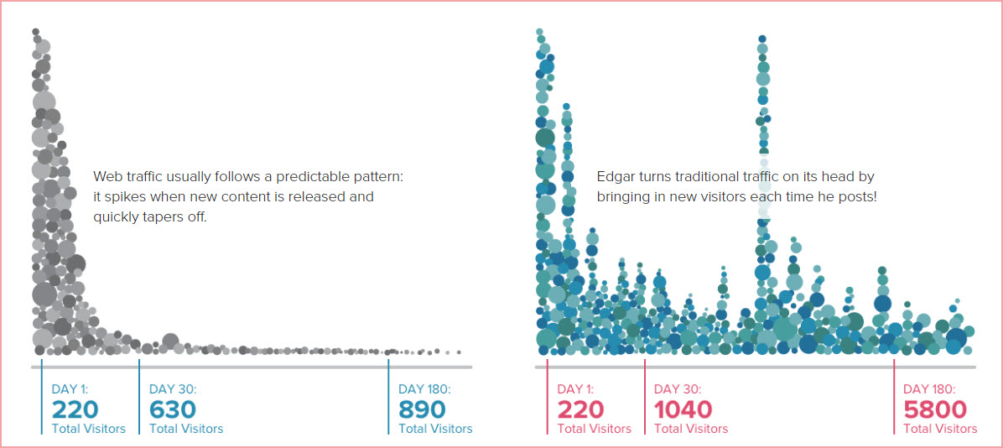
MeetEdgar is a one of the most high-powered social management and content solutions, a completely new concept in content creation and sharing (endorsed by the likes of ProBlogger’s Darren Rowse).
MeetEdgar automatically categorizes and organizes your content into your own custom, powerful library; then publishes it at regular intervals. You can add bulk content or connect your RSS feed. You can publish to Facebook, Twitter and LinkedIn, plus ten more channels of your choice; and if you have a premium account, you can add up to twenty-five more channels.
MeetEdgar is “designed to work” in Chrome, Firefox and Safari and does not need additional plugins. It includes a bookmarklet tool too.
You can schedule updates at specific times, and check your daily MeetEdgar queue to ensure that what is going out is ideal. And it bills itself as both newbie-friendly, for those just getting started with content marketing; and perfect for pros with advanced sales funnels.
You can store unlimited updates and images up to 3mb and 1,000 pixels on their longest sides. You can also do all your post scheduling from Edgar, specifying which categories to glean for updates, and leave it up to Edgar to start recycling your older updates to new audiences.
Starter plan: $49 per month if paid annually ($99 per month, for the Premium plan)—but you can request a custom quote for your business.
- NinjaOutreach
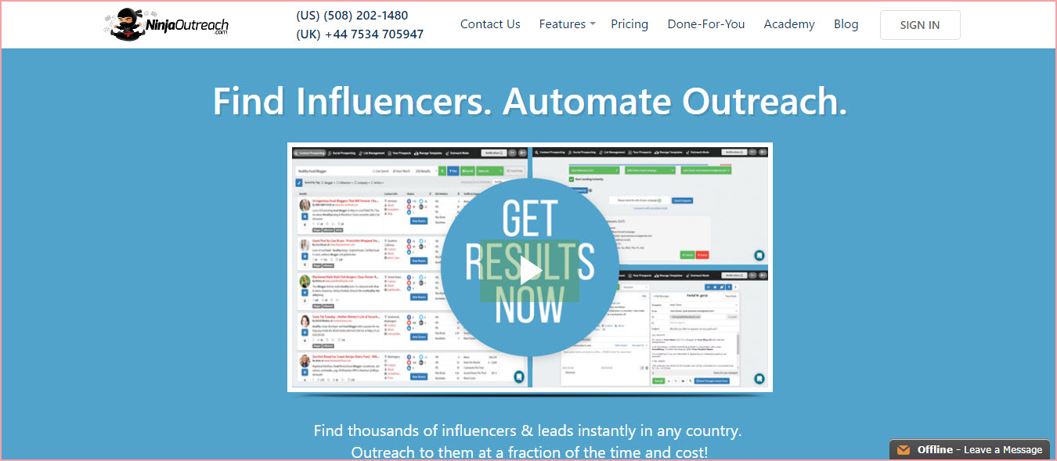
Helps you find influencers and automate your outreach. It’s an alternative to BuzzStream that some are saying is much simpler to operate. It costs more for a single-user starter plan than BuzzStream, but instead of 1,000 contacts allowed and 30 prospecting searches, you get 1500 contacts plus unlimited emailing and searches.
Helps in effectively performing the following:
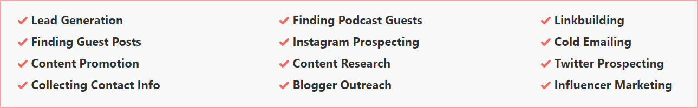
Price: Plans start at $49 per month.
14-day unlimited free trial.
- Social Media Widget
If you prefer social media share buttons in your sidebar, try this five-star-rated widget. Lets you add buttons for the big five: Facebook, Twitter, Google+, LinkedIn and Pinterest.
Easily Customizable and extremely mobile-friendly.
Free download via your WordPress Dashboard from the WordPress plugins directory.
- Hootsuite
There are several dashboard-run social media management suites active at the moment. Hootsuite is one of the oldest. It has been going strong since 2008—and it is still one of the most reliable, handling the most social media channels, and is available in either iPhone or Android App form, in addition to website form. It integrates with MailChimp, Twitter, WordPress and Zendesk, and boasts strong security protocols.
There are two potential drawbacks, however: It contains no autoresponder function (though it does integrate with MailChimp) and you are forced to use its native Ow.ly URL shortener—which is notorious for on and off popularity with major social networks; even itself banned from LinkedIn for a while.
You can upload bulk posts via .CSV files.
Price: Plans start at $9.99 per month
- SocialOomph
SocialOomph is the latest contender in the world of dashboard-based, social media managers. Many prefer it to Hootsuite for its simpler, easier and some say more powerful, analytics. Plus it notifies you of retweets and @mentions. It does contain an autoresponder, and offers strong telephone and online support.
If you work mostly from your mobile or Google+ is one of your major channels, you might prefer to stick with Hootsuite: Unlike the latter, SocialOomph has no mobile apps and doesn’t yet include Google+. Security seems to be lacking too.
One advantage if you prefer MS Word to MS Excel: You can upload bulk posts via .DOCX files via an easy, WYSIWYG system.
Price: $17.97 every two weeks. 7-Day free trial.
- TweetDeck
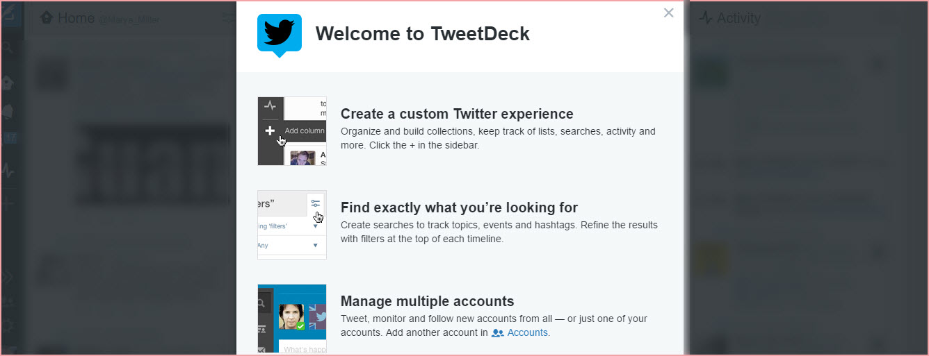
Another oldie-but-goodie—perfect for those who concentrate most heavily on promotion and contact via Twitter.
Once you are logged into Twitter, you will see multiple streams in your Twitter feed, all in one central screen (to call it a “dashboard” is misleading). In the default setting, you’ll see columns showing as many streams of feed as you like: Messages, Notifications, your Feed, Activity—you can have up to nine timelines comfortably on your screen (or less!) As long as you are signed on via your Twitter account, you can access your TweetDeck streams at one simple click.
You can manage multiple accounts, as well as share with your team. (You keep control of permissions at all times.) You can turn on alerts, pre-schedule posts, track searches, manage lists, mute users or terms to eliminate unwanted noise, choose your theme, and more. And Tweetdeck also supplies iPhone/Android Apps.
Free.
- Schedugr.am
If you have multiple Instagram accounts, and Instagram is a big part of your online strategy, you might want to check out Schedugr.am. It supports multiple accounts and allows you to upload images or video to be scheduled for later. Manage all your logins with one simple click. Easy-to-use image editor. Integrates with Canva.
Price: Varies on your needs, but averages out to $20 per single Instagram account.
7-Day free trial.
- Social Sticky
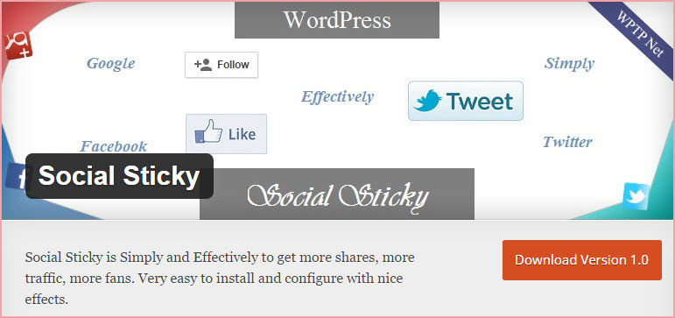
Animated sticky sidebar. A lightweight, lightning-fast plugin for Facebook, Google+ and Twitter as well as many other social networks, powered by jQuery (which means no conflicts).
- Social Media Email Alerts
This five-star-rated plugin allows you to select various social networks and receive real-time email alerts whenever your site is submitted to any social network. You can set up your own rules.
Tracks at the page level.
Free via WordPress plugins directory.
- Social PopUP – Facebook, Twitter and Google+
This WordPress plugin displays a pop-up whenever a new user visits your site, offering your visitor your Facebook, Twitter and Google+ follow links.
You can set the plugin to repeat at any interval you like (example: 6 days) for each user, so that they are not overwhelmed with the pop-up every time they visit.
You can also choose to display or not display a Close button.
Free via WordPress plugins directory.

- Everypost
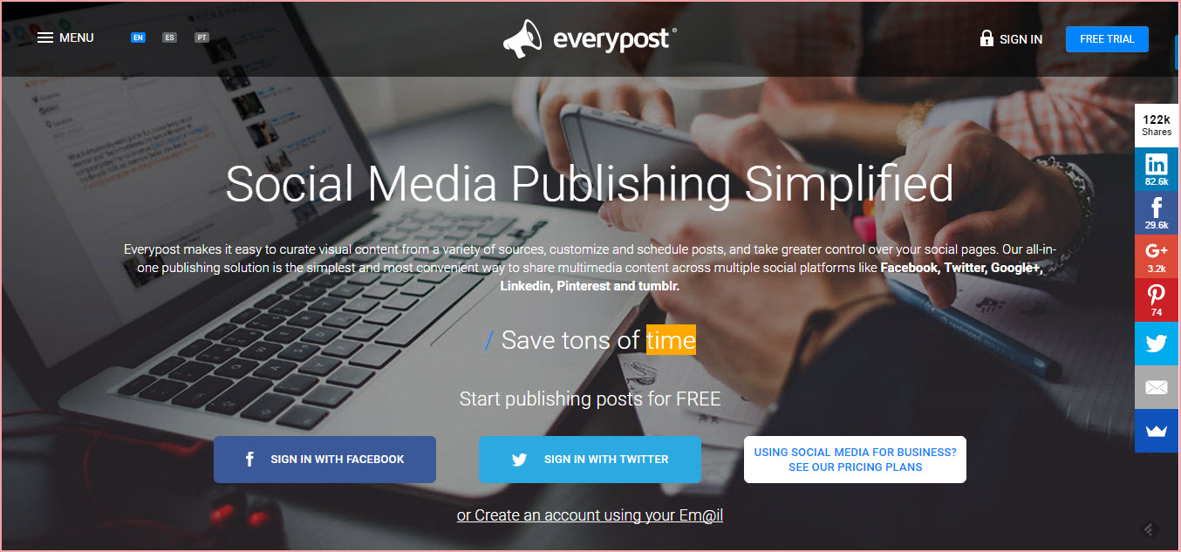
This time-saving social media tool really does simplify your social posting. Practice content curation; customize, schedule and publish posts; perform social analytics and even collaborate with team members using this powerful tool. Share quickly across multiple platforms: Facebook, Twitter, Google+, LinkedIn, Pinterest and Tumblr.
Pricing: Free account for one user. Paid plans start at $9.99 per month.
14-day free trial.
- Zapier
This tool allows you to automate information between your various web Apps, saving time and simplifying functions. Linking your web Apps is simple: Enable them with “just a few clicks” to share information back and forth, helping you to build seamless workflows.
Works similarly to IFTT: You specify a trigger action and assign a command, so that it performs an action—and then sends it to the appropriate online service or social network.
- Bit.ly
When you need an URL shortener, Bit.ly is still one of the most reliable and glitch free. It’s easy to use—you can log in with Twitter—and (the real advantage) gives you powerful stats about your shortened URLs. Plus you can customize them, if preferred. (Free!)
- Recurpost
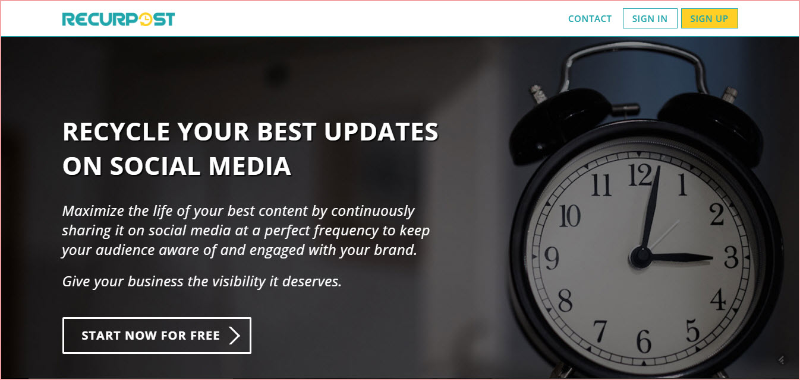
This powerful alternative to MeetEdgar allows you to:
- Create a content library of your best posts, promotions, links, videos, quotes
- Add, delete and edit your content library at any time
- Set your schedule for reposting your content at the most optimal time intervals for you and your audience
- Track, tweak and test
- Create reports
- Manage feeds
- Use your editorial calendar
(There is also a Chrome plugin at the Chrome web store.)
FREE.
Finally, do take the time to research and create a targeted social media plan first, determining your main goal and listing all the networks you want to share across. That will make it easier to filter out and choose the tools and Apps that are just right for your individual needs.
Remember, it’s just the tools: It’s how wisely you use them.
Happy social streamlining!

